PROGRAM
import cv2
image = cv2.imread("flower.jpg")
if image is None:
print("Image not found")
else:
gray_image = cv2.cvtColor(image, cv2.COLOR_BGR2GRAY)
equalized_image = cv2.equalizeHist(gray_image)

cv2.imshow("Original Image", gray_image)
cv2.imshow("Histogram Equalized Image", equalized_image)

cv2.waitKey(0)
cv2.destroyAllWindows()
COMMANDS USED
cd Desktop
cd opencv
python histogram_equalization.py

INPUT
The input image used in this experiment is:
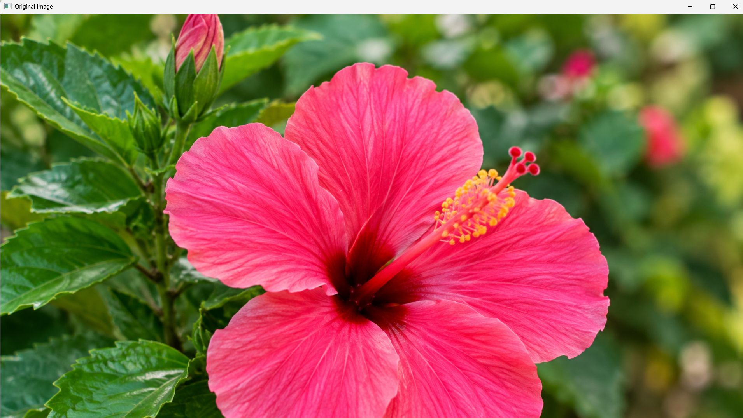
flower.jpg
OUTPUT
The program displays two windows:
1.Original Image
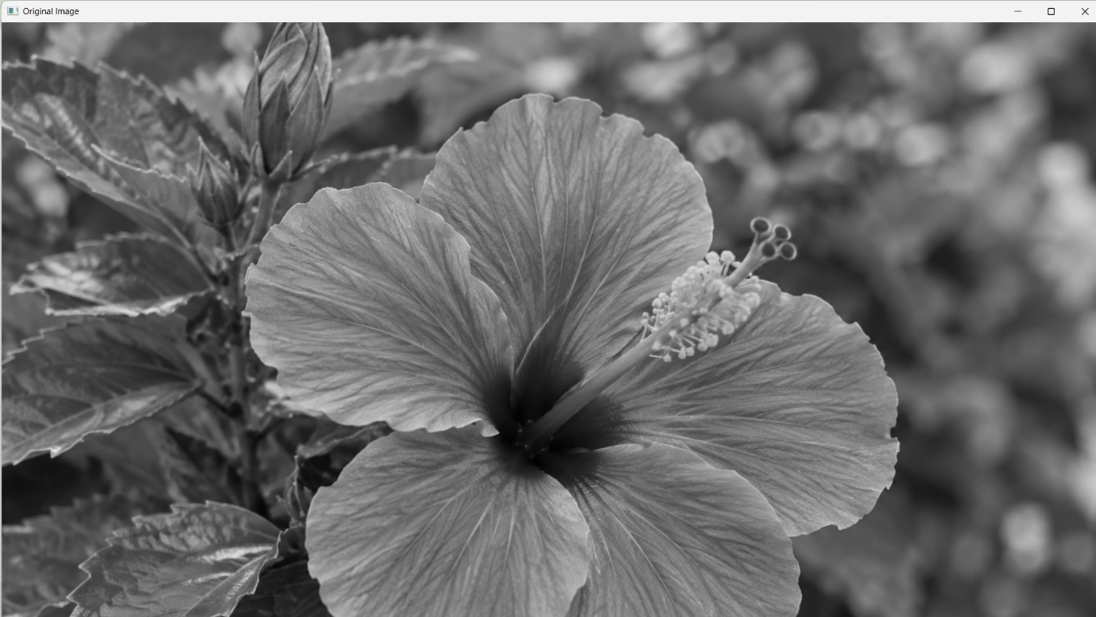
2.Histogram Equalized Image
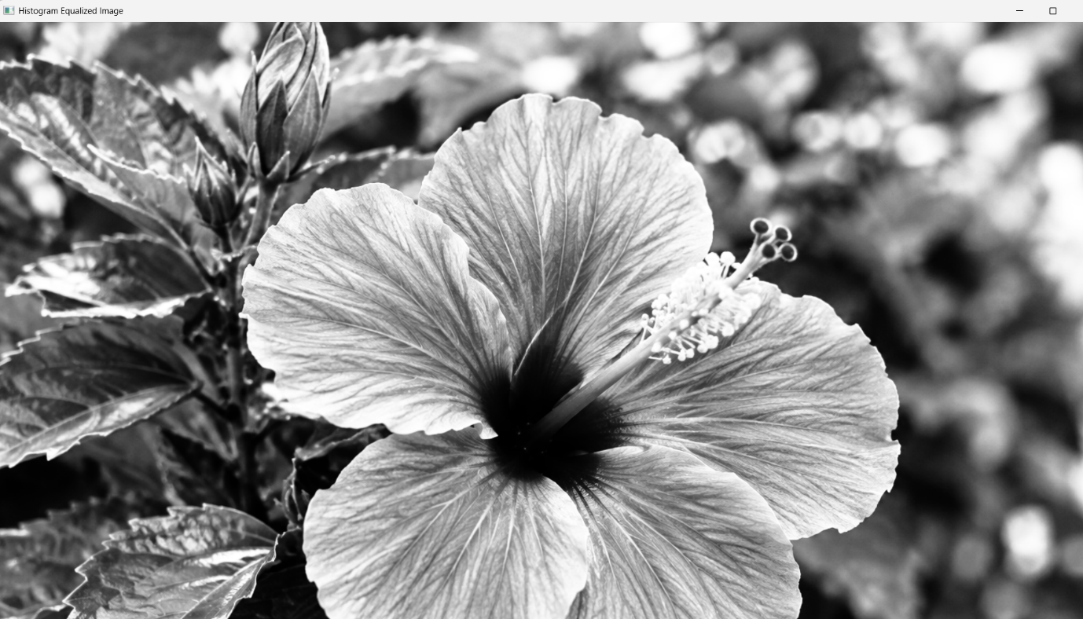
RESULT
Thus, histogram equalization was successfully implemented using OpenCV, and the original grayscale image was compared with the histogram equalized image.

